**Add a New Username:**

**Setup menu:** **Employee Setup**

Add the new employee’s username here

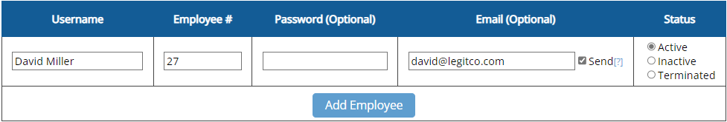

Employee #’s are required for the use of readers, and often required for payroll exports.

Employee #’s cannot be duplicated.

Click “Add Employee” to add new username.

After saving, the new Username will drop down into the list of employees.

Make sure your filters are set to “Active” and “All” to see everyone.

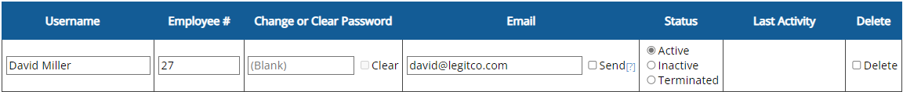

When password is set:

* Password will always be hidden with asterisks.
* To reset, just type a new one and save.
* To let the employee set their own, checkmark “Clear” and save.

When password is blank:

1. Employee logs in for the first time with **NO** Password.
2. Employee will then be prompted to create a password.

**Re-activate an Old Username:**

**Setup menu:** **Employee Setup**

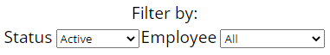To reactivate a username, utilize the filters on the Employee Setup page to view all usernames, including Inactive and Terminated.



* Set username back to Active
* Save Changes

**Setup menu:** **Employee Restore**

(or)

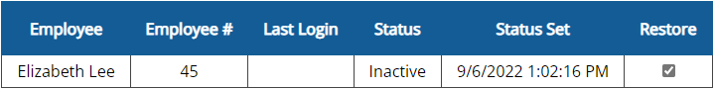You can also restore Inactive, Terminated, and even Removed/Deleted usernames from the Employee Restore page.

* Checkmark “Restore”
* Save Changes