Whether your employee is on leave for a few months, seasonal, or has been terminated from the company, if they aren’t using the system, you’ll want to make sure that username isn’t being charged on monthly invoices.

**Setup menu: Employee Setup**

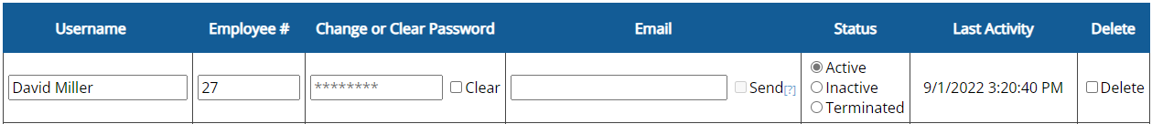

Terminated: **Not** charged on monthly invoices

(usually used for workers no longer employed)

Inactive: **Not** charged on monthly invoices

(usually used for seasonal or intermittent workers)

Active: Charged on monthly invoices

1. Set to **Inactive** or **Terminated**
2. Save Changes

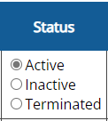

Remember, the username may be charged to one more invoice if there was usage within the billing cycle.

Usernames can be re-activated in Setup, **Employee Restore**.

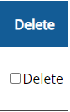

**What about “Delete?”**

Usernames should only be deleted if they were accidental, a duplicate, or otherwise not needed for use or historical purposes. After deletion, the system wait 18 months, and will then purge all data associated with the username.

For any username with actual time card data, we suggest “Inactive” or “Terminated.”